**Data Science Project**

Movie Recommendation System

**Secondary Research:-**

1.Project Finalized:

* In the finalization of the project, a comprehensive analysis of web data was conducted. This process involved finding valuable information from various online sources, utilizing advanced tools and techniques.

1.Data Collection

* User Data :- Gather information about users including their viewing history, ratings and their preference.
* Movie Data:-Collect data on various movies, including genres and ratings.

2.Identify reliable sources

* Rely on various websites like TMDB, Kaggle, and various other websites.

3.Literature Review

* Explore existing literature related to our topic, understand past research, theories, and methodologies employed by other researchers.

4.Applications

* Netflix Recommendation System
* Amazon Prime movie recommendation system

**Primary Research:-**

1.Survey Conducted:

* We conducted a Google Form Survey so to get a Quick Hint of Public/Customer Reviews based on their Experience’s on Multiple Platform’s across the Internet.

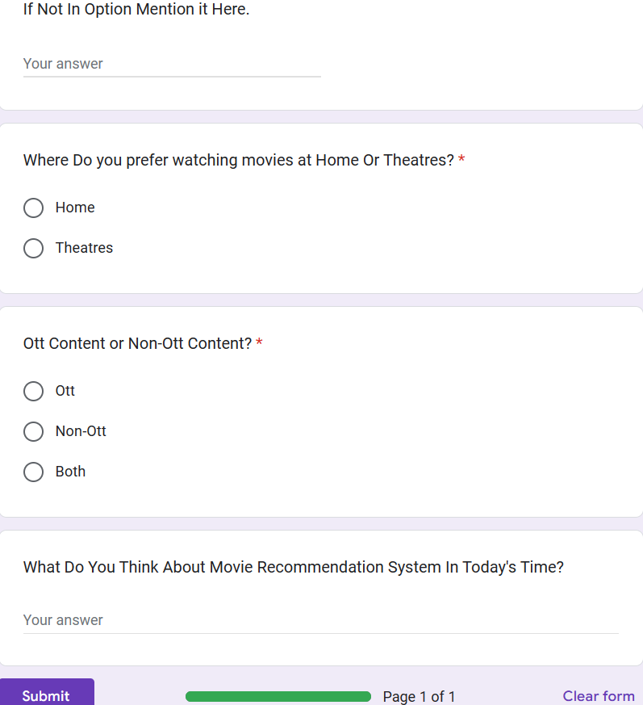

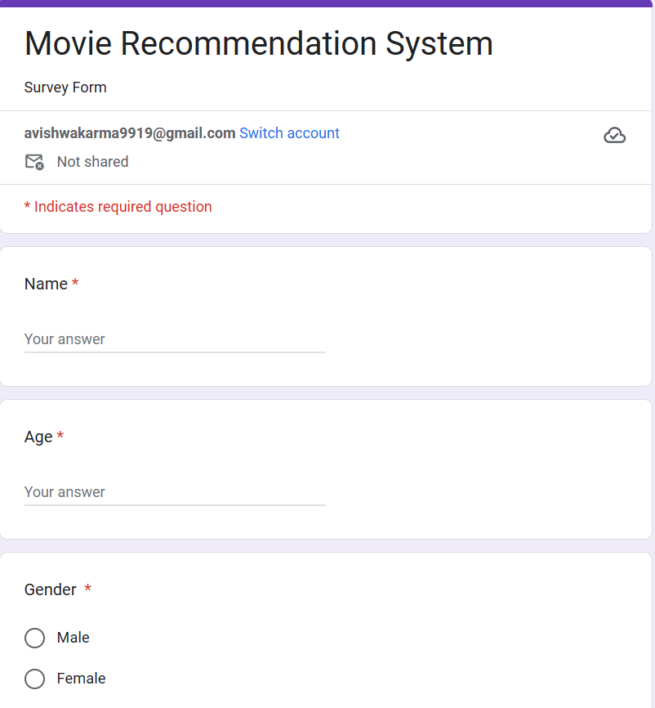

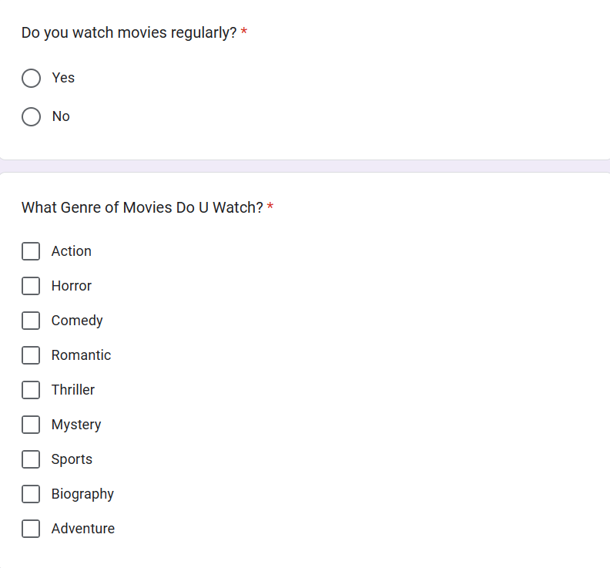

**Result Of the Survey:-**

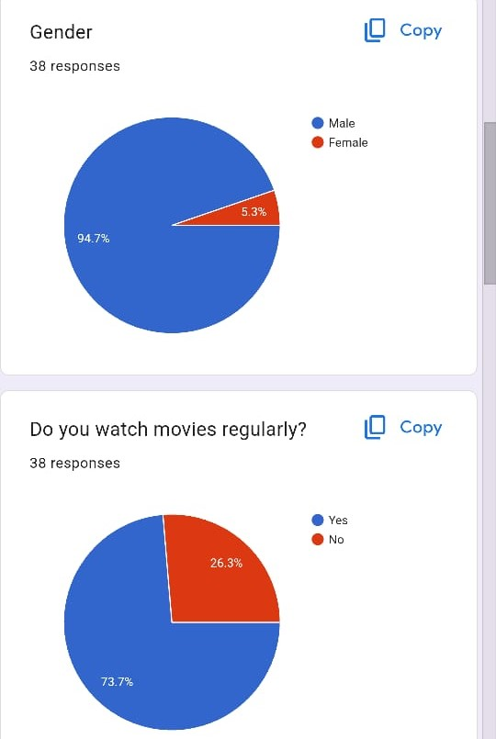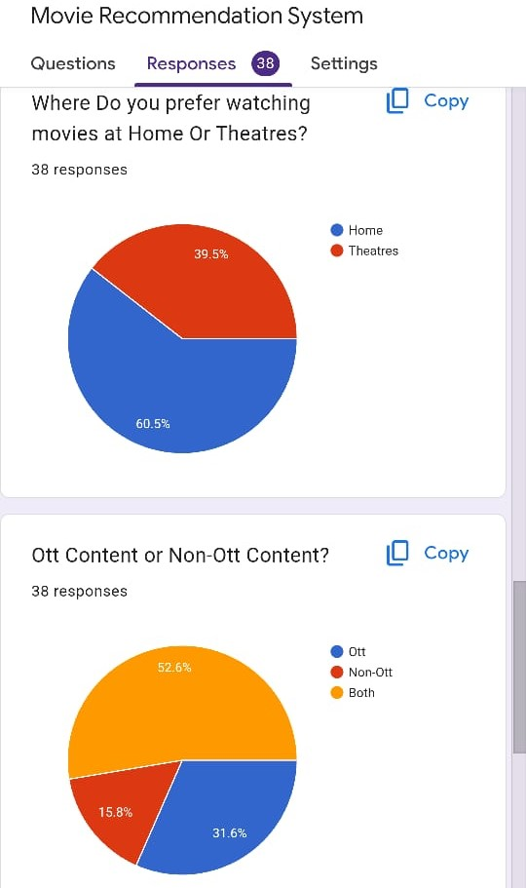

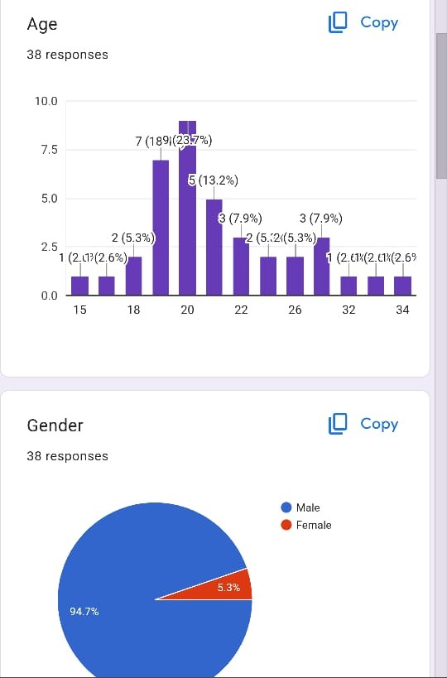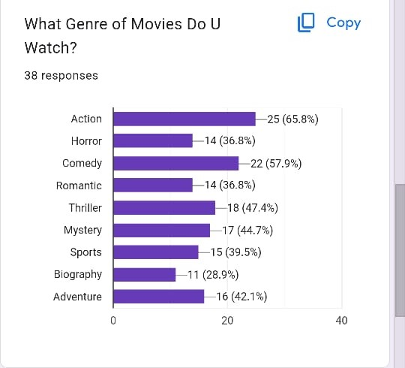

**Brief:-**

1.What is Movie Recommendation system?

* It is an software that suggest movies to users based on data analysis of their preference.

2.Which data are used and how does it work?

* An Csv data of movie that contains the movie name, genres along with their year of launch.It analysis the userdata and movie features then uses algorithm to recommend the movie.

3.Is the source of the data reliable and reputable?

* Ensure the data comes from trustworthy sources to maintain the credibility of your analysis.

4.What is the quality of the Csv data?

* Check for completeness, consistency, and accuracy. Noisy or incomplete data can significantly affect the analysis results.

5.Are you compliant with data privacy laws and ethical guidelines?

* Ensure that the data you are using is anonymized and that you are not violating any privacy regulations.

6.Why Data Science is crucial for Recommendation System?

* Data science processes and analyses large dataset to understand user behaviour, extract pattern and make accurate predictions for personalized movie recommendations.

**Flow Chart:-**

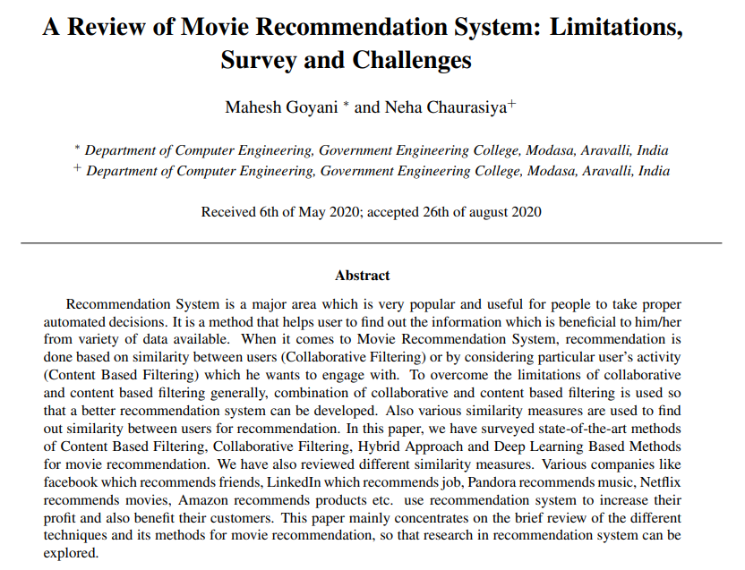**Literature Review 1:-**

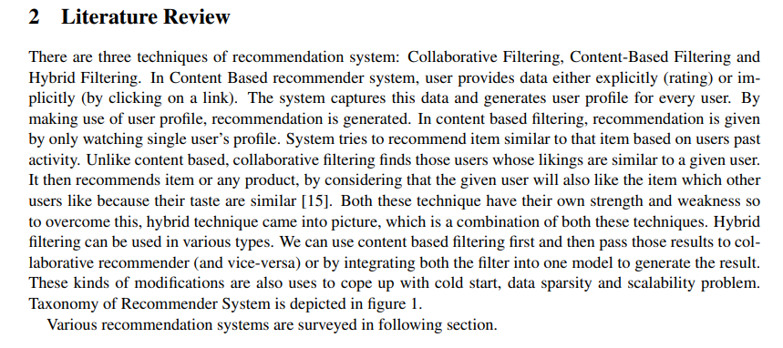

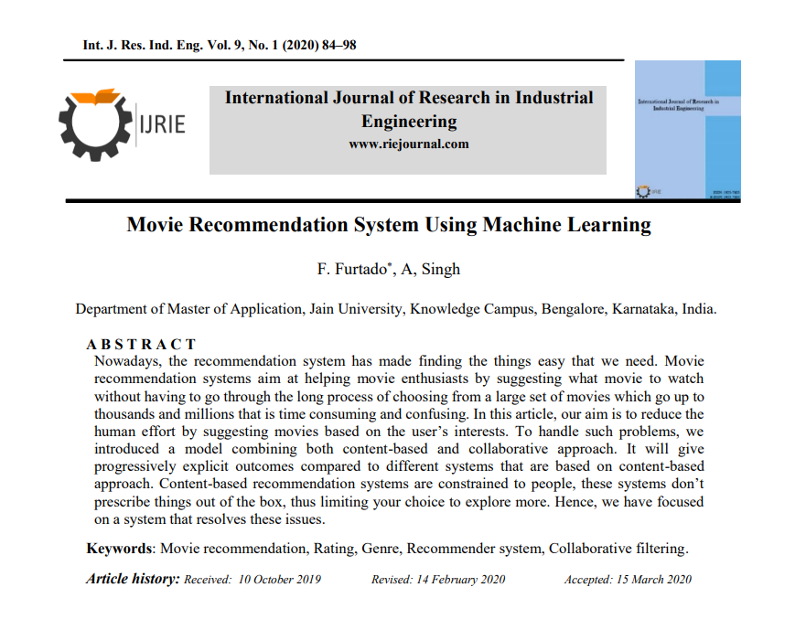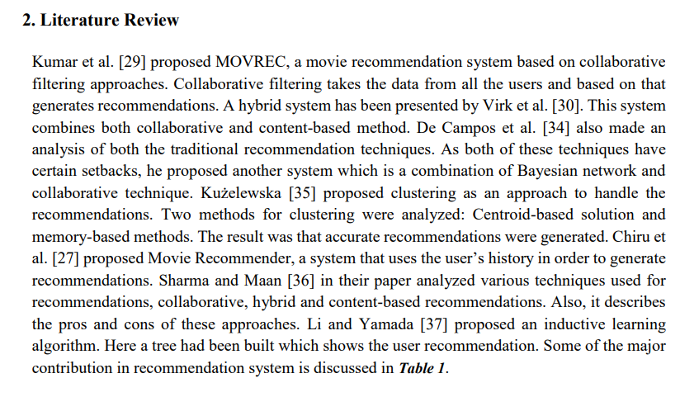**Literature Review 2 :-**



**Brain Storming:-**

**1.Data Collection:**

* **Data Sources:-**Consider sources like various website like tmdb, Kaggle or website having Csv dataset along with movies.

OR

You can collect the data with the help of Web Scrapping by using ApI keys and converting the text file into json and start the algorithm.

**2. Data Pre-processing:**

* Cleaning the data:-Removing the Brackets, Special characters commos,etc.

**3. Movie Recommendation Techniques:**

1. Collaborative Filtering:

* User-Based: Recommends movies based on users with similar tastes.
* Item-Based: Recommends movies similar to those the user has liked.

2. Content-Based Filtering:

* Recommends movies based on movie attributes and user preferences

3.Association Rule Mining:

* Identifies relationships between different movies based on user viewing patterns.

**Ideation:-**

**Real-World Impact:**

* Movie recommendation systems have a real-world impact, influencing how people consume entertainment. By understanding the techniques behind these systems, one can contribute to creating more effective and personalized recommendations.

**Research Papers and Publications:**

* Explore research papers in the field of recommendation systems. Many academic researchers contribute innovative ideas and techniques for improving recommendation algorithms..

**Product Reviews:**

Extract customer reviews from ott platforms like Amazon Prime, Netflix to understand movies about specific genre.

**Forums and Blogs:**

Scrape discussions from forums like Reddit or niche blogs to analyse movies on various genre.

**Exploration:-**

**1.User Behaviour Analysis:**

* Investigate user behaviour by analysing the distribution of user ratings and the number of ratings per user.
* Explore the most-rated movies and identify any patterns

**2. Genre Preferences:**

* Examine the distribution of movies across genres and identify the most popular genres.
* Explore whether certain genres have higher average ratings than others.

**3. Exploratory Data Analysis (EDA):**

.

* Explore the popularity of different genres over time.
* Analse the distribution of movies across different categories and identify trends.

**4.** **Temporal Trends:**

* Analyse how user preferences and movie ratings change over time.
* Identify trends in the release of movies and their impact on user ratings**.**

**5.Feedback and Improvement:**

* Continuously update your scraping and analysis process to keep up with changing review formats or user behaviour on other movie recommendation platforms.

**Note:-** **Mock-up or Model is not Required as it is a Software-Based . Product.**